FOLDER: Data/ Cases

FILE: Rabies_WGS84_Singlepart

Description: Rabies cases from 1987 to 2016, spatial points dataframe.

Scripts: 1_Exploration cases, 1B_Subset_cases_DEU_CZ_and_POL

Output: maps, plots and subset files (subset_cases.shp, subset_cases.df.csv and subset_cases.kml)

* In Europe

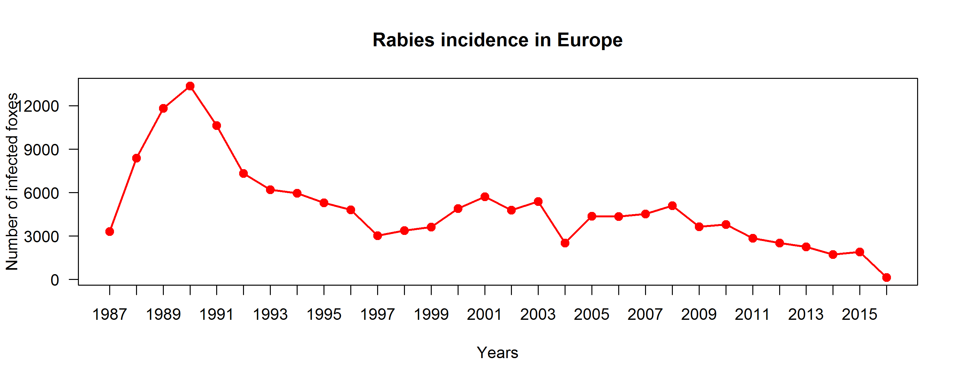

*Peak in 1989

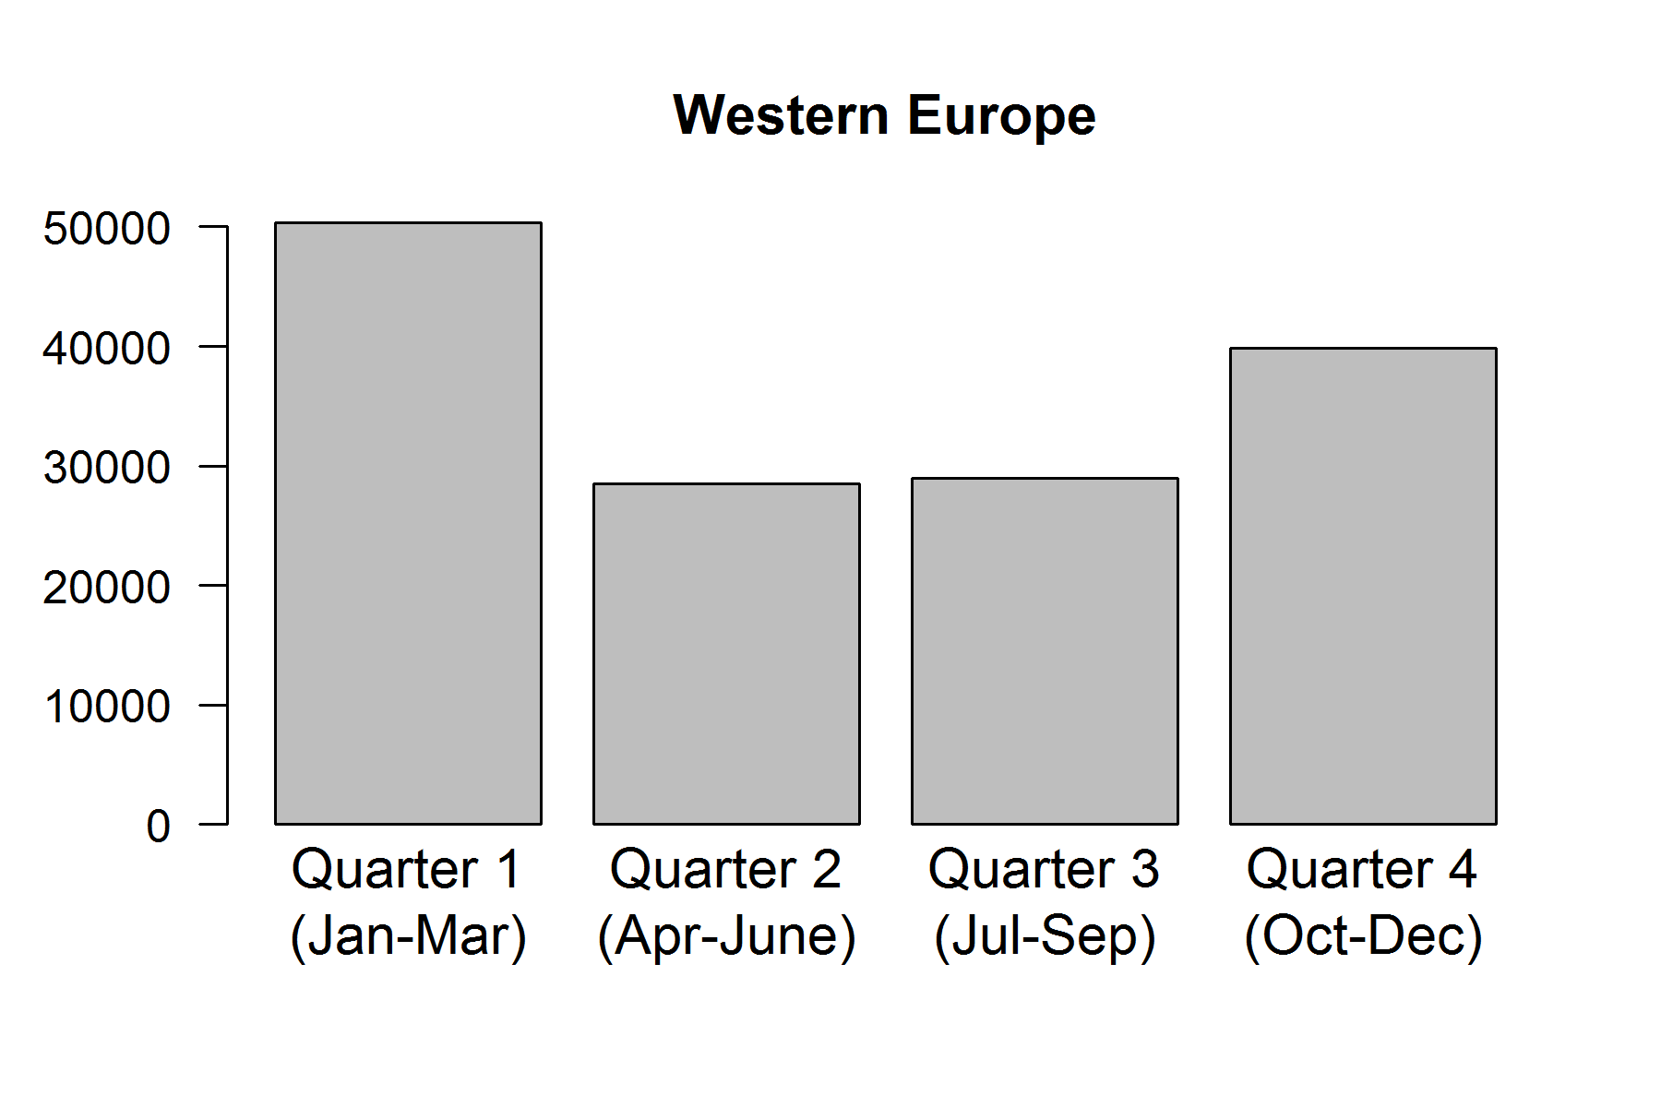

* In Q1 and Q4 there were more cases
* In Germany, Czech Republic and Poland

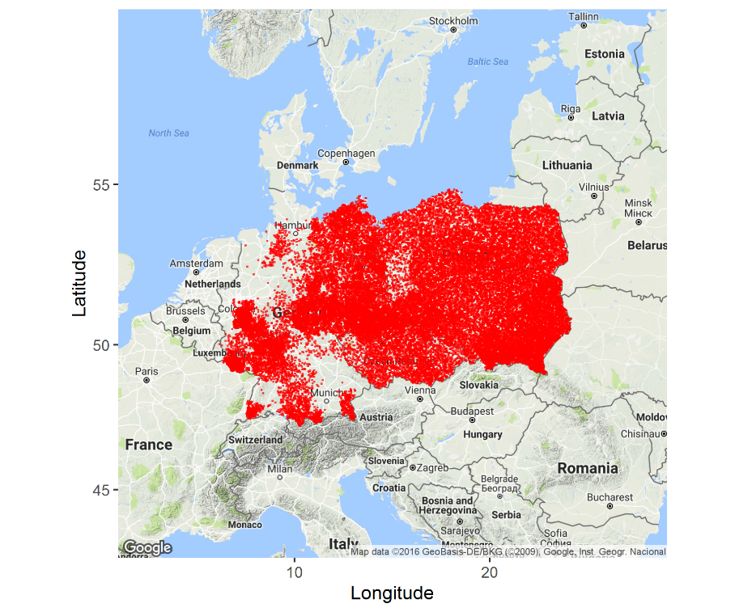

* All Poland covered

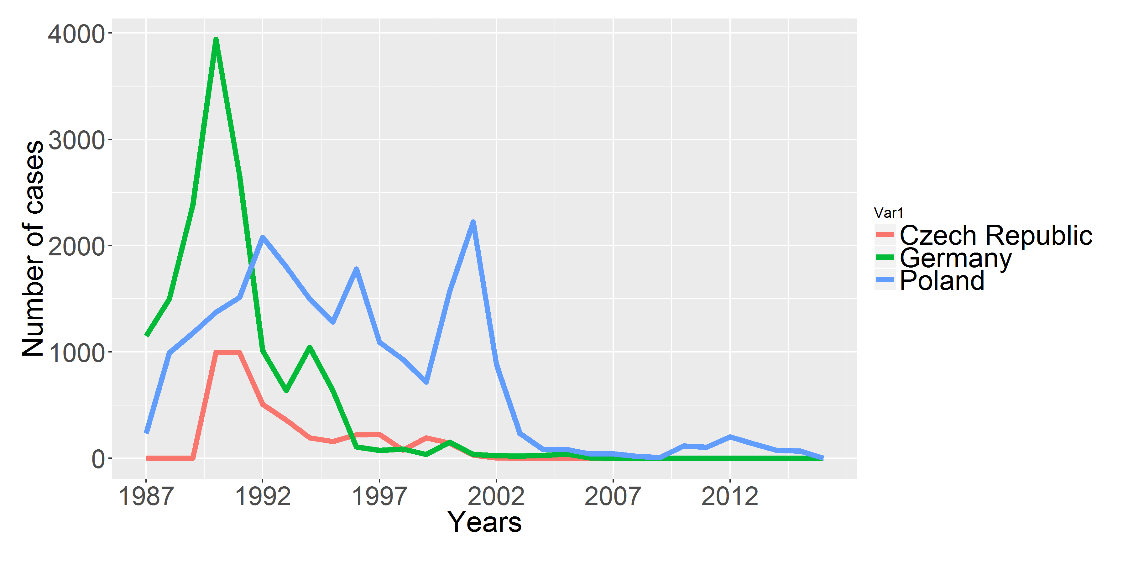

* Germany from 1989